Town of Thompson
DRAFT Recreation Development Plan March 2019

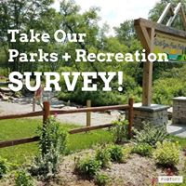
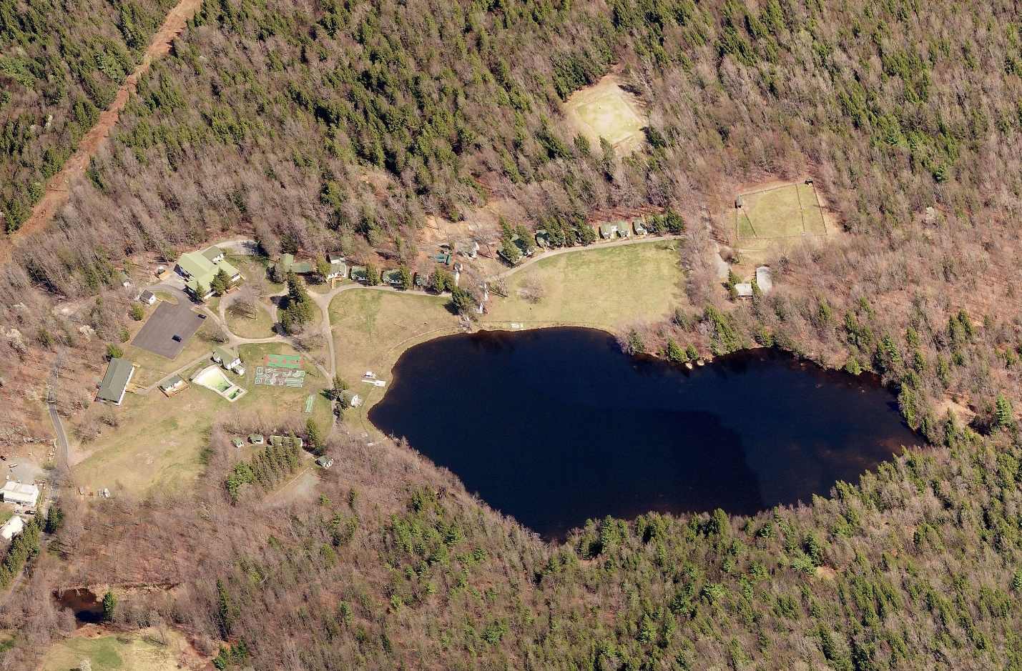

Table of Contents
1.0 Introduction 1
2.0 Planning Framework 1
2.1Approach 1
2.2 Planning Area Description 2
2.3 Planning Process 3
3.0 Parks Classification and Standards 3
3.1 Benefits of Parks and Recreation 3
3.2 Park Classifications 4
3.3 Development Standards 5
4.0 Current Park and Recreation Facility Needs Analysis 6
4.1 Existing Park and Recreation Facility Inventory 7
4.2 Needs Assessment 9
4.3 Current Parks Department 10
4.4 Other Local Nonprofit and Private Agencies 11
5.0 Survey 11
5.1 Structure 11
5.2 Respondents 12
5.3 Survey Results Description 12
5.4 In context 18
6.0 Recommendations 19
7.0 Implementation 21
7.1 Project Priorities 21
7.2 Other properties 22
7.3 Project Costs 23
7.4 Maintenance Costs 23
7.5 Financing Strategy 23
7.6 Staffing needs 25
7.7 Partnerships 25
8 CONCLUSION 27

Appendices
Appendix A: Former Camp Jened Options and Estimates
Appendix B: Public Survey Questions
Appendix C: North Street Commons
Appendix ??: Other items – Dillon Park, Town Park??

Introduction
The Town of Thompson has a long history as a scenic resort area and recreation destination in Sullivan County, New York. Communities benefit from open spaces and spaces for community recreation. The Town has recently purchased 142 acres of land, the former Camp Jened summer camp (15-52 Jened Drive), and would like to make this land accessible to public use for recreation. This report will assist in determining the best use of that land within the overall local public recreational opportunities.
What is a Park? The word “PARK” can mean several things, depending on the situation at hand. Park is often defined as an area of land set aside for public use and can have an expanded definition as: 1) a piece of land with few or no buildings within or adjoining a town, maintained for recreational and ornamental purposes; 2) a landscaped city square; 3) a large tract of rural land kept in its natural state and usually reserved for the enjoyment and recreation of visitors (freedictionary.com). The definition of “PLAY” is to engage in an activity for recreation and enjoyment rather than a serious or practical purpose.
How does the new opportunity offered by the former Camp Jened property best fit into the current availability of public parks? What needs to occur to improve or enhance existing parks? What are the needs in the community? Basic planning for development of the land as park space in the context of other area park and recreation features and the needs of the community is presented.

- Planning Framework

2.1Approach
The planning process has evolved in the past year. The Town of Thompson formed an advisory committee, the Parks and Recreation Committee, in May 2018. Originally the former Camp Jened property was the singular focus of development planning; however, in discussions with the Town appointed Parks and Recreation Committee, it became apparent that the former Camp Jened should not be developed without consideration of other locally available public parks. The approach presented here includes looking at all area parks in a “big picture” way, reviewing the questions: what open space and facilities are available? what is lacking? what can the open space at former Camp Jened provide. Existing Town and Village parks are utilized by residents of both municipalities and one Village-owned park is actually located in the Town. Area sports leagues are open to youth in both municipalities, and Monticello Central School District recreation facilities serve children throughout the district, which includes sections of the Towns of Thompson, Forestburgh, Bethel, Fallsburg and Mamakating.
State lands, private camps and recreational facilities for homeowner’s associations have not been studied in depth for this report. The availability of state lands are part of the background recreational resources of the area and outside the influence of the Town. Similarly, private camps and HOA facilities are not open to the public and likewise not under the control of the Town.
The November 2017 Town of Thompson Parks and Recreation Study looked at current publicly available parks and recreational facilities and needs related to new residential developments that may contribute to population growth and need for more services. Descriptions of the existing area public parks were included in that Study and reproduced within this plan (included in Section 4.1).
In order to gain input from the community, a Town of Thompson Parks survey was made available on-line, and two Visioning workshops were held in 2018. The survey and the results are described in Section 5.0, and the survey is included in Appendix B.

2.2 Planning Area Description
For a comprehensive view of the currently available parks and recreation facilities, the area covered in this report encompasses the overall Town of Thompson, including the Village of Monticello which is located in the geographical area of the Town.
According to the 2015 American Community Survey population estimates, the Town of Thompson, excluding the Village of Monticello, has a population of 8,582 persons. That population is 15,308 when the Village is included. According to the American Census Survey 5-year estimate for 2013-2017, the Median Household Income (MHI) in the Town of Thompson is $42,175 and the MHI of the Village of Monticello is $31,169 (as compared to the County MHI of $53,877).
Estimates for summer seasonal population based on the number of seasonal housing units, rises to 20,561 persons in the Town and Village, in other word, 34.3 percent of the summer population is seasonal. In the Town itself, excluding the Village, the summer population increases by 4,986 persons (58% of the population). In the Village, the summer population increases by 267 (3.9 % of the summer population). The increase in summer population creates increased pressure on area parks in the peak outdoor recreation season, especially in the Town.

2.3 Planning Process
As this development plan was to be created in the context of all public parks in the Town of Thompson including the Village of Monticello, a survey was created to gather public input from park users and the community on what they liked or didn’t like about the currently available parks and the perceived needs.
Information gathered from the survey and visioning workshops was put together with information from the National Recreation and Park Association (NRPA), as well as available information on the condition of the facilities at the former Camp Jened, to provide a basic plan for moving forward with development of that property. Guidelines from NRPA on parks per population (see Table 3.3, 4.2a and 4.2b) were utilized in this review, however the focus will be on meeting the needs within the Town of Thompson.

Parks Classification and Standards

Benefits of Parks and Recreation
There are many individual and community benefits to public parks. The availability of open space and community spaces for recreation increases individual and community well-being and supports economic improvement.
Researchers from the Regional Plan Association and Quinnipiac College Polling Institute, in 1995, queried nearly 2,000 people from around the country about quality of life. The major elements cited as crucial for a satisfactory quality of life were low crime with safe streets and access to greenery and open space. “Across the nation, parks and protected open space are increasingly recognized as vital to the quality of life that fuels economic health.” (Garvin and Berens, Urban Parks and Open Space).
According to real estate experts; “Nationwide, easy access to parks and open space has become a new measure of community wealth—an important way to attract businesses and residents by guaranteeing both quality of life and economic health. Real estate industry analysts confirm quality of life as a determining factor in real estate values and economic vitality. One 1998 industry report calls livability “a litmus test for determining the strength of the real estate investment market . . .If people want to live in a place, companies, stores, hotels, and apartments will follow.” (ERE Yarmouth and Real Estate Research Corporation “Defining New Limits: Emerging Trends in Real Estate.” Cited in; Lerner, Steve, and William Poole. The Economic Benefits of Parks and Open Space. San Francisco: The Trust for Public Land, 1999.)

Park Classifications
The National Recreation and Park Association (NRPA) is a national, non-profit service organization dedicated to advancing parks, recreation and environmental efforts that enhance the quality of life for all. In 1996, the NRPA published the Park, Open Space and Greenway Guidelines which presented a model of typical park classifications as well as recommended service levels based on population. However, the NRPA determined that one set of standards does not fit all communities nationwide especially in urban areas. They recommended that each municipality develop customized Level of Service Standards that reflect the specific conditions and unique nature of their community. The following NRPA Standards should therefore be viewed as general guidelines which can be customized by individual communities, see Table 3.3;
Mini Parks – Mini parks generally address specific recreation or open space needs, such as playground or passive recreation for specific groups such as tots or senior citizens. Typically, these parks cover less than one acre and have a service radius of less than ¼ mile. A mini park may have a small play structure, shelter, swings and a jungle gym, with a small area of flat open space. Easily walkable, typically no parking.
Neighborhood Parks – Neighborhood parks are considered the basic unit of a community’s park system and provide a recreational and social focus for residential areas. These parks provide space for informal active and passive recreational activities. The typical service radius for neighborhood parks is between ¼ and ½ mile. Neighborhood parks adequate in size to accommodate the requisite facilities often contain at least 5 acres; between 5 and 10 acres is considered optimal.
School Parks – School facilities can help meet neighborhood park needs, particularly when located in areas not served by other parks. Playgrounds, open space, play fields and basketball courts at schools often function as a neighborhood park and attract residents from the area. Communities should not depend on school parks to meet the neighborhood park need, but could consider developing neighborhood parks in conjunction with or adjacent to school sites.
Community Parks – Community Parks typically include areas of diverse use and environmental quality/conservation. Such parks meet community-based recreation needs, may preserve significant natural areas and often include areas suited for intense recreational facilities. Community parks generally contain between 20 and 50 acres and serve a variety of needs. The typical service radius of a community park is approximately ½ mile to 3 miles. Typical criteria include adequate size to accommodate activities associated with neighborhood parks, but with space for additional activity, and a special attraction that draws people from a larger area, such as a pond or lake, ice skating rink, trails, special environmental or cultural features or specialized sports complexes.
Special Use Parks – Special Use Parks cover a broad range of facilities oriented toward a single use, including cultural or social sites and specialized facilities.
Regional Parks – A regional park is an area of land preserved on account of its natural beauty, historic interest, recreational use or other reason, and under the administration of a form of local government. It may be contiguous with or encompassing natural resources area.

  - Development Standards
The general NRPA recommendation of a minimum of 10 acres of neighborhood/community parkland per 1,000 residents has become a common standard used by many communities as a guide. The 2017 NRPA Agency Performance review indicates that the typical park and recreation agency has 9.6 acres of parkland per 1,000 residents. Note that school district and regional parks are not typically included in this calculation.

Table 3.3 NRPA Traditional Parkland Classifications
Type | Service Area  Radius | Desirable  Size | Acres/  1000 residents | Site Characteristics and Facilities
Mini/Pocket  Parks | < ¼ mile | < 1 acre | 0.25 – 0.5 acres | Playground and/or passive recreation for specific groups such as tots or senior citizens. Easily walkable, typically no parking.
Neighborhood Parks | ¼ - ½ mile | 5 – 10 acres | 1 – 2 acres | Serve surrounding neighborhoods with open space and facilities such as basketball courts, children’s play equipment and picnic tables.
Community Parks | 1 – 2 miles | 25+ acres | 5 – 8 acres | May include areas for both intense and passive recreation such as athletic complexes, swimming pools, hiking trails and areas for viewing, sitting, and picnicking.
Regional Parks | Several Communities | 200+ acres | 5 – 10 acres | Contiguous with or encompassing natural resources.
Special Use Areas | No applicable standards | Variable | Variable | Area for specialized or single purpose recreation such as campgrounds, golf courses, etc.

Current Park and Recreation Facility Needs Analysis
The Town of Thompson Parks and Recreation Study provided overview level information on each of the parks within the Town of Thompson and Village of Monticello. Other private recreational facilities also exist in this area as do recreational facilities associated with Homeowners Associations, however, these facilities are not public nor under the control of the Town or Village and are not part of this Plan for public facilities.

Existing Park and Recreation Facility Inventory
Town of Thompson Park – The Town of Thompson owns and operates a 173-acre community park located on Town Park Road near the northern town border. Park facilities include a new community building and playground, two pavilions, rest rooms, barbeque pits, an apple orchard and picnic areas, hiking/cross-country ski trails, a pedestrian bridge over the East Mongaup River, soccer/softball practice areas, and a 20’ x 50’ swimming pool. The swimming pool was acquired from a private citizen about 2003 with the intention of using it for swim lessons, not as an open community pool, as its maximum capacity is 56 people. The swimming pool is only open during the summer day camp program which is operated by the Sullivan County YMCA. Approximately 200 children register for the seven-week day camp session each summer. In 2010 the Monticello MAFCO-Football league created a youth football field in the south end of the park with lights and bleachers. The Town is currently adding new signage and hiking/cross-country ski trails and repairing storm and wind damage on the east side of Town Park Road.
Dillon Park and Pool – The Village of Monticello owns and operates Dillon Park, a 13.6-acre community park located in the Town of Thompson on the south side of Dillon Road. The park includes a 5-acre pond and fishing dock, a pavilion, gazebo, barbecue pits, picnic area, basketball court, playground with tire swing and slide, skate park, and a 30’ x 60’ swimming pool. The pool is open during July and August from noon to 7p.m. with free admission.
De Hoyos Memorial Park and Pond – The Village of Monticello owns and operates De Hoyos Park and Pond, a community park located on Hay Street at the west end of the Village. The park is comprised of two parcels. The main recreation parcel is 11.5-acres and includes a pavilion, barbeque pit, toddler playground and older child playground, 6 tennis courts (fee for use, in poor condition), a 2-acre pond stocked with fish, frogs and turtles, walking trails around the pond and a scenic overlook. The park also includes a 13.6-acre wooded parcel at the west end of Hay Street which is undeveloped. There is interest in improving a trail to Dillon Park.
Ted Stroebele Recreation Center – The Ted Stroebele Center serves the Village as a community center rather than a recreation facility. It houses the parks and Recreation Department offices, Village Court, Meals on Wheels program, Senior Citizen activities, and meeting rooms for community groups and non-profit organizations. In February 2019, an ice-skating rink was created behind the center in a cooperative venture between the Village, Town, County and Cornell Cooperative Extension. The Sullivan County YMCA is working with the Village on a plan to renovate the Center and studying options for nearby gym space.
Monticello Central School District (MCSD) recreational facilities – Monticello Central School district athletic fields and indoor recreation facilities are currently not open for general public use but may be rented by community groups when not scheduled for classes, practice or games by district sports teams. School affiliated groups, volunteer non-profit community groups, government agencies and local scouting organizations are exempt from rental fees. Other organizations and youth groups have special contractual agreements with the district or have a reduced fee schedule. The village Recreation Department currently uses the MCSD gyms for free K-5 indoor recreation programs. Discussions are on-going on potential facilities use agreements.
Monticello high School and Robert J. Kaiser Middle School Campus includes a football field, baseball field, two softball fields, four soccer fields and track and field facilities. The ball and soccer fields are rented out to community groups during the entire outdoor season. The Monticello Little League uses the High School fields 1 and 2 for their six divisions; T-Ball, Rookie, Minors Softball, Minors Baseball, Majors Softball, and majors Baseball. The Mamakating-Monticello AYSO uses the High School soccer field.
Somerville Athletic Field includes a soccer/football field, softball field, track and field facilities, and two tennis courts. The tennis courts are currently in need of repair
Kenneth L. Rutherford Elementary School facilities include two softball fields, basketball courts, a soccer field and two playground areas.
George L. Cooke Elementary School facilities include a baseball field, soccer field, miscellaneous courts and two playground areas.

Needs Assessment
The November 2017 Town of Thompson Parks and Recreation Study showed the total estimated seasonal population in the Town of Thompson to be approximately 20,561 persons. Based on the NPRA recommendation of 10 acres per 1,000 residents, the Town would need approximately 200 acres of public parkland to serve this population. As shown in Table 4.2a, the Town of Thompson including Village facilities currently has just under 200 acres of public parkland, very close to the NRPA acreage guidelines.

Table 4.2a Town of Thompson / Village of Monticello Public Parks
Name | Type | Acres | Facilities
Thompson Town Park | Community | 173 | Community building, two pavilions, playground, swimming pool, picnic areas, hiking/cross country ski trails, football field, soccer/softball areas.
Dillon Park | Community | 13.6 | Pavilion, basketball court, skate park, playground, picnic areas, swimming pool, pond and fishing dock.
De Hoyos Park | Community | 11.5 | Pavilion, two playgrounds, tennis courts, pond, walking trail
TOTAL |  | 198.1

Table 4.2b Town of Thompson / Village of Monticello / MCSD Athletic Facilities
Facility Type | NRPA Standard  per Population | Recommended for 20,000 Pop. | Existing Quantity
Baseball Field | 1 per 5,000 | 4 | 2
Softball Field | 1 per 5,000  (if also used for youth baseball) | 4 | 6
Basketball Court | 1 per 5,000 | 5 | 3
Football Field | 1 per 20,000 | 1 | 3
Playgrounds | 1 per 2,000 | 10 | 9
Soccer fields¹ | 1 per 10,000 | 2 | 9
Swimming Pools | 1 per 20,000 | 1 | 2
Tennis Courts | 1 per 2,000 | 10 | 8
Track | 1 per 20,000 | 1 | 2
Notes: Boldface indicates facilities for which the existing number may be fewer than necessary according to NRPA Standards. (1) Soccer fields include those in the school district that may or may not be accessible for public use.

NRPA traditional recommendations for the number of specific types of recreation facilities per population are shown in Table 4.2b. The Study identified the need for additional parks and recreation facilities to support recreational demands in the areas of baseball fields, basketball courts, playgrounds and tennis courts using NRPA Standards. Actual needs for sports facilities in the Town will depend upon where the fields or courts are located, current condition and ownership differences. Note that NRPA guidelines state that “Communities should not depend on school parks to meet the neighborhood park need, but could consider developing neighborhood parks in conjunction with or adjacent to school sites”.

Current Parks Departments

Town of Thompson – Total of three year-round employees, and one Parks Superintendent. May have an extra person in the summer season. The Department provides maintenance, mowing and care of trees and shrubs, at the Town Park (also paint the pool) and Town Hall. Parks staff also assist the water and sewer department with maintenance when needed. The Superintendent and a shared secretary receive applications for group use and schedules community use for the Town Park and Community Building.
Village of Monticello – One staff contact listed on website, forms for requesting group use at DeHoyos Park and the Ted Stroebele Recreation Center are online, to whom do those forms go? What are the duties of the Parks and Rec contact? What department provides maintenance?

Other Park Users
Sullivan County YMCA has a 155-acre facility at 98 wild Turnpike, Rock Hill. The facility includes year-round hiking trails, boating, fishing, and a small ropes course. Environmental education programs and community group use is available upon request. Currently the gates are closed unless there is a program being held at the facility. A recently built 3,000-square foot family center can provide a variety of programs ranging from outdoor education to arts, fitness classes and school vacation programs. The YMCA is a community-based not for profit organization.
Monticello Area Football and Cheerleaders Organization (MAFCO) is a youth-based competitive football and cheerleading organization for children between the ages of 5 and 14 years of age. Although based in Monticello, includes players living anywhere in Sullivan County. Town of Thompson Park Football Field at 179 Town Park Road.
American Youth Soccer Organization (AYSO) – Liberty United Soccer Club, Harris, NY, Mamakating/Monticello AYSO – apparently play in fields in Grahamsville, Liberty, Eldred, Glen Spey and Warwarsing.
Little League - The Monticello Little League uses the High School fields 1 and 2 for their six divisions: T-Ball, Rookie, Minors Softball, Minors Baseball, Majors Softball, and Majors Baseball. The Mamakating-Monticello AYSO uses the High School soccer field.

Survey
A survey and two visioning workshops were held to gather input from the community. According to sign-in sheets, 32 people participated in vision workshops (September 15, 2018, Monticello Fire Department and September 17th Rock Hill Fire Department). Participants shared ideas on a variety of issues and opportunities with the current park system.
  - Structure
The survey consisted of twelve questions; six asked the respondents to select an answer from pre-chosen options (choose all that apply), and six of the questions were open ended in which the respondent was able to write in their own response. An example of the survey is included in Appendix A. The Town utilized SurveyMonkey to create and post the survey. Note that most of the questions involving choices from a list allowed the respondent to “check all that apply”, as well as add a comment if “other” was chosen.
  - Respondents
One-hundred and two (102) people answered questions in the on-line survey, which is 0.7% of the year-round population or 0.5% of the summer seasonal population. This is a relatively low response rate; an average response rate for on-line surveys can be approximately 29%, depending on the intended audience.
Respondents self-identified (Question 12) as being from ZIP codes in the Town of Thompson/Monticello geographical area. As shown in Table 5.2, 49 of respondents live in Monticello, while another 36 live in Rock Hill, the remainder identified as living within various other municipalities within the Town of Thompson.
Table 5.2: Survey respondents live in these zip codes
ZIP code | Number of Respondents living in ZIP
12701 (Monticello) | 49
12775 (Rock Hill)/ 12738 (Glen Wild) | 40
12742 (Harris) | 3
12777 (Forestburgh) | 2
12763, 12789, 12760, 12721, 12754, 12734, 12747, 12719 (other areas within Town or Sullivan County) | One each

Survey Results Description
One-hundred and two (102) people answered survey questions on-line. Overall feedback indicates a desire to create a community-based park system that is accessible to everyone, with activities for all ages and abilities, and dissatisfaction with current state of recreational facilities, especially in the Village.
Question 1: Park visits (101 answered; 1 skipped)
Forty-four percent (44.6%) said they visited a park in the Town of Thompson/Village of Monticello several times a year. Fourteen percent (14.8%) said they visited a park weekly in the spring to fall seasons, while another approximately fourteen percent (13.8%) said they visited monthly in the same time period. Few said they visited in the parks in winter. Thirty-seven percent (36.6%) said they never go to the parks. See Figure 5.1.
Figure 5.1: Frequency of Park Use

Question 2: Which Park (99 Answered; 3 skipped)
Of the parks actually visited, twenty-eight percent (28%) said they visited Town of Thompson, while twenty-three (23%) percent visited DeHoyos and 6% visited Dillon Park. Twelve percent (12%) noted they used Somerville Field while fifteen percent (15%) said they did not visit the parks. See Figure 2.

Figure 5.2: Which Parks were Visited

Question 3 & 4: Current Likes & Dislikes
Participants were asked what they like and dislike about the current parks. Note that participants did not always state the name of the park on which they were commenting. Participants tended to like the trails at the Town of Thompson Park, and pavilions and picnic spaces. People thought having parks be accessible from their neighborhoods was important, as were age-appropriate playgrounds. Participants noted they enjoyed attending activities and BBQs at the parks.
Many participants noted that the parks need maintenance and upkeep, especially for tennis and basketball courts, as well as bathrooms and pavilions, at DeHoyos and Dillon. Several noted that they felt unsafe, and thought that drug deals were happening in the Village parks. Others noted that the parks were either overcrowded or under-utilized. Many noted that the parks were not accessible to their neighborhoods.
Participants in the workshops and on-line survey liked the pools at Dillon and Thompson, but disliked the usage schedules that made access to the pools and parks difficult; the summer camp at Thompson and closed gate at Dillon. Respondents stated again and again the importance of upkeep and maintenance on the facilities at the existing Parks, and the existing state of disrepair in several, especially Dillon and DeHoyos.

Question 5: Sports facilities (95 Answered, 7 skipped)
For the question on additional outdoor sports facilities, among the choices offered, participants approximately equally favored development of tennis courts, basketball courts and soccer fields (10% to 12% for each), while also expressing favor for baseball/softball fields, track and field facilities, pickleball courts and skateboard parks (7 to 9% each). Racquetball courts, volleyball courts and frisbee golf were chosen to a slightly lesser extent (3 to 5% each). Note that each participant had the opportunity to select more than one sport facility they would like to see developed. Comments in response to having selected the “other” category included an outdoor pool or beach, dog park, and multi-use trails for walking and bicycling. See Figure 5.5.
Figure 5.5: Outdoor Sports Facilities

Question 6: Recreational Opportunities (100 Answered, 2 skipped)
Participants noted they were interested in several different additional recreational opportunities for potential development; each participant could select more than one from the given list. Hiking trails, boating/canoeing/kayaking, fitness area and dog park were each selected ten to fifteen percent of the time (10 to 15%). Lake swimming, picnic areas, ice skating/hockey and fishing were selected between six and nine percent of the time (6 to 9%). Those who chose “other” noted an interest in paved paths and fitness trails, as well as an indoor recreation facility and pool, and smaller neighborhood parks. See Figure 5.6.

Figure 5.6: Interest in Additional Recreational Opportunities

Question 7: Recreational Programs (77 Answered, 25 skipped)
When asked what recreational programs they would like to see, 77 participants responded and noted organized hikes/walks (15), organized bike rides and safety lessons (3), and organized ski trips (2) as activities they would like to be available. Twenty-six (26) said they would like to have swimming lessons, while ice skating/hockey (3), tennis (2), pickleball (1) and chess (1) were other lessons indicated. Interest was expressed in basketball (7) leagues, as well as baseball (4), soccer (4), track (2), volleyball (2), frisbee golf (1) and dog training club (1). Participants thought that spaces for theater (2), concerts (2), community gardening (2), crafts and arts (2) and double-dutch jump rope (1) would be good additions to the parks. Four (4) participants noted the importance of having walking trails and activities for senior citizens.
It is possible that the question, which used the wording “example, an organized basketball league, swimming lessons or organized hikes”, influenced the number of responses in those categories.

Question 8: Rentable Community Space (87 Answered, 15 skipped)
When asked to choose from a list what types of rentable spaces they would like to be developed, thirty-three percent (33%) said an Indoor Sports Complex, twenty-four percent (24%) said Indoor Event Space with Kitchen, twenty percent (20%) said Camping Cabins, eighteen percent (18%) said Open Pavilions and five percent (5%) said Bandshell. See Figure 5.8.

Figure 5.8: Interest in Rentable Community Space

Question 9: Example Municipal Parks (76 Answered, 26 skipped)
When asked about memorable visits to other municipal parks, participants wrote about other parks as disparate as NYC Central Park and Albany Pine Bush. Important components were clean, well-maintained bathrooms and grounds, with well-marked trails, posted maps and use rules. Activities for all ages and physical abilities, playgrounds located near picnic areas and sports fields were also mentioned.

Question 10: Vision (71 Answered, 31 skipped)
Participants were asked to express their vision for a future Town/Village park system – many would like to see the parks be community centers for all ages and abilities, organized activities, access available from neighborhoods. The availability of both indoor and outdoor recreation (all season), public beach. Larger parks with sports fields, pavilions and open space as well as smaller parks with playgrounds and gazebo benches; clean/maintained/accessible/inclusive system where community can gather for activities and events.

Question 11: Additional Park Development Ideas (56 Answered, 46 skipped)
Only 56 of the 102 survey takers responded to the request that they share other ideas or comments that would help develop plans for a future park system. Some answers reiterated ideas on activities to have available, however, some stated that parks should be better maintained, more publicized, and more accessible, a place for ALL residents. Some thought that seniors, and children of all ages and abilities, and economic class also need safe parks they can walk to or get to by bus. Some respondents suggested free rides (Health pass from Wellness visit) on bus to get to parks, or the use of grant funds and/or nominal use fees to help improve and maintain parks. Some put forward the idea that the Town and Village should collaborate, involve the School system, and get kids involved in activities and maintenance projects. Others suggested a strong recreational program, a parks commission, fenced in dog parks, rentable spaces such as a kitchen and gathering areas. Overall, location and cleanliness are important to a park system for all.

  - In context
To put these results in context, the survey captured a small percentage of the population, most of which are from the Village of Monticello or Rock Hill; nevertheless, the survey serves as a first overall assessment. More community input will be needed going forward on specific park action plans. It is possible that Question 7, with example answers provided, was a leading question which led to the emphasis on particular activities in the answers. Analyses of the open-ended question responses can be somewhat difficult as respondents often did not respond to question at hand, and often skipped open-ended questions.

Recommendations
There are many individual and community benefits to public parks. The availability of open space and community spaces for recreation increases individual and community well-being and supports economic improvement. The Town recognizes the importance of parks and green space, and purchased the former Camp Jened Property with this idea in mind. This planning report was developed to look at the development of local parks for the community as a whole.
Results of the survey also indicated that many people may not be aware of the current recreational opportunities within the Town. An NRPA study, Awareness and the Use of Parks (2019), found that “lack of awareness” was the second most-cited reason people did not use parks in their community (first-cited was “lack of time”). The report lists use of local media, the internet, e-mail, newsletters, activity guides and word-of-mouth as ways people learn about parks. The Town should take advantage of the Town website and social media, especially, to promote the Town Park and provide information to park users on the available facilities and trails. Future community input will be needed in parks development, for which the internet, local papers and shared information with interested organizations will be important.
Were the Town concerned only with the Town of Thompson Park, the Town would need additional capacity in terms of playgrounds and sports facilities. There are current pool access issues with operation of the YMCA camp, making the pool a potential benefit to the community but not accessible to local residents not involved in the summer camp. The YMCA could be interested in working with the Town on staffing the pool beyond day camp hours for lessons available to the community. However, the pool is small and was not originally intended to be utilized as an open community pool.
There is an expressed interest in the Town park providing paved walking/bicycling paths for people of all ages. Nearby New York State Forest Lands properties provide trails for hiking, horseback riding, cross country skiing and biking, as well as access for fishing.
The property at the former Camp Jened can provide canoe/kayak/paddle boat access, perhaps through a concession if those boats are to be rented. The property can also provide for a community center, playgrounds, swimming beach, and, if needed, ball fields and soccer fields. These options need further discussion and development, and may need to be completed in phases.
The total estimated summer season population in the Town of Thompson including the Village is approximately 20,561 persons. Based on the NPRA recommendation of 10 acres per 1,000 residents, the Town would need approximately 200 acres of public parkland to serve this population. As shown in Table 4.2a, the Town of Thompson including Village facilities currently has just under 200 acres of public parkland, very close to the NRPA acreage guidelines. Note that the layout of the Town is very different from that of the Village; looked at separately each has a different “situation” regarding parks and recreation space.
The Town, not including the Village has 8,582 people and a 178-acre Town park. At NRPA guidelines of 10 acres per person (or 85.8 acres) the Town has more than sufficient acreage for public parks, though it may be lacking in the number of sports fields and playgrounds. The existing Town Park is, however, located in the northern portion of the Town and requires transportation for residents to get to the park. During the summer season, when the population in the Town increases to 13,568, the acreage of the Town park is still sufficient for the summer population, but with more pressure for use of the facilities. The swimming pool is only open during the summer day camp program which is operated by the Sullivan County YMCA. According to guidelines in Table 4.2b, there are enough pools in the Town of Thompson (counting the Town Park and Dillon Park), but the issue may be access, maintenance needs, and community perceptions. The YMCA is willing to discuss how their staff might provide lessons to the community at the Town Park outside of the summer camp hours.
The Village, alone, has 6,726 people and 25.1 acres of park. At NRPA guidelines of 10 acres per person (67.3 acres), the Village is considerably lacking in public park land and facilities. The Village parks are, however, located nearer to people to access by walking, without the use of a car.
In order to meet the overall community, Town and Village, need for both parks that are more accessible to neighborhoods and parks with larger sports and recreation facilities, cooperation between the Town and Village is recommended. The Survey shows that Town residents use Village parks and Village residents use the Town Park. Smaller Neighborhood parks could be made more accessible for gathering, picnics, music, playgrounds. Town and Village parks are utilized by residents of both municipalities and one Village-owned park is actually located within the Town. Area sports leagues are open to youth in both municipalities, and MCSD recreation facilities serve children throughout out the school district, which includes sections of the Towns of Thompson, Forestburgh, Bethel, Fallsburg and Mamakating. Cooperation between the Town and Village could involve agreements regarding maintenance and upkeep, need upgrades, as well as cooperative development and operation of Recreation activities/sports leagues/community activities/classes.

Implementation

  - Project Priorities by Park
Several parks need upgrade and maintenance first. The following sections are lists of actions ideas that can be taken in the short-term at each park, pulled from the survey, workshops and Park Committee meetings. Parks in the Town and Village and School District are discussed together with future potential cooperative planning in mind. Information on plans for the North Street Commons is included in the Appendix.
Town of Thompson Park (Town)
- Options to pool/playground use issue – work with YMCA, add a second public pool? Open existing pool to public after summer camp hours? Expand trails
- Park Road maintenance
- Improve access to lower park where the playground, BBQ area and pole barn are located
- Update restrooms
- Add a fenced area for a dog park
- Add Trail Map to Town website, and ensure Trail itself is well marked

Camp Jened property (Town)
- Community Center with meeting room and kitchen
- Playgrounds
- Concession for boating on lake
- Sports fields if determined there is a community need/desire

DeHoyos Park (Village)
- Repair tennis court
- Repair pole barn
- Add basketball court
- Add new playground equipment
- Skateboard park repaired or relocated?

Dillon Park (Village)
- Repair fence
- Add lighting
- Repair basketball courts
- Add Pickleball area
- Remove old equipment and add new playground for different ages/capabilities
- Replace pool – fix security so park can be open if pool is not
- Fix up restrooms
- Add fenced area for a Dog park
- Pond – bridge needs to be repaired and fishing dock added; algae issue is likely related to stormwater runoff, a situation that needs some investigation to find a solution
- Nature Trail – clean up, add info signs
- Connection trail between DeHoyos Park and Dillon Park

Somerville Fields (School District)
- Repair tennis courts, racquetball court
- Repair track loop
- Update baseball/softball fields
- Rejuvenate grass on soccer fields
- Add basketball court
- Add new lighting
- Add a pickleball area, or replace racquetball with pickleball
- Add benches
- Install bathrooms
- Add new scoreboard

There is a need for updating existing facilities and provision of maintenance going forward. Discussions on shared facilities are underway and can help meet community need.
Camp Jened could fulfill the need for a community center with rentable meeting/activity space, playgrounds and a public beach; and additional outdoor sports facilities if future planning efforts decide there is need. The buildings on the property are not in condition to meet current standards and will need to be demolished. Appendix A includes some basic estimates in cost. Several potential Jened property future layouts are also provided in Appendix A.
To benefit in the short-term from the purchase of the former Camp Jened, the property could be made accessible for limited use for picnics/boat launch while keeping decrepit buildings out of bounds, prior to the development of long-term plans. This approach would require site monitoring to ensure safety and avoid mis-use of the existing buildings.

The Town and Village would benefit from organized recreation programs shared among already existing entities. There are several local Town/Village/School/Youth sports organizations that could benefit from the development of sports facilities and run sports activities. A Parks and Recreation Director and staff are likely needed to coordinate usage at the facilities and keep activities going. Community volunteers are also a potential asset, and can work with staff.
  - Other properties

Consider the addition of smaller pocket parks that are accessible within neighborhoods, playgrounds for children of different ages and picnic areas where the Town or Village owns vacant land. A study of available Town lands did not identify any currently Town-owned vacant parcels that are available for development of parks. Longer-term planning may identify private parcels that could be acquired for parks development, in the Town or Village. The Sullivan County Land Bank Corporation goals include returning vacant properties to community use, and could partner to provide land for neighborhood parks.
The Town owns a 4.5-acre parcel, south of Highway 17 on the Neversink River, known as the Bridgeville site. This parcel could be minimally developed for kayak/canoe access with a parking area, with access from Bridgeville Road. Anecdotally, there is use of an input area upstream on the Neversink mid-way to Fallsburg; it is likely this land is private. There are no immediately obvious take-out points downstream. Longer-term planning will be needed in order to establish other area locations for River access, upstream and downstream.

Project Costs

Project costs will be different for each park, depending on what short- and long-term development plans are made for each. Estimates for the costs of planned improvements can be utilized in budgets or grant applications to funding organizations. Basic site preparation costs for the Jened Property are supplied in Appendix A.

Maintenance Costs

Maintenance costs will need to be calculated for each park and its facilities, repairs, periodic replacements for picnic tables, playground equipment, landscaping, trash pickup, etc. The Town budgets approximately $35,000 for maintenance at the Town Park; including mowing, picnic tables and painting the pool annually.

Financing Strategy

What funds are available in Town or Village annual budget for updating Parks? For maintenance of Parks?
The Town has a dedicated Parks and Recreation fund, recognizing there are many individual and community benefits to public parks. The availability of open space and community spaces for recreation increases individual and community well-being and supports economic improvement. Grants may also be available to assist with costs of updates suggested in Section 7.1.
New York State makes community development funding available through the Regional Economic Development Councils (https://regionalcouncils.ny.gov/). Planning, development and improvement of parks are activities eligible for funding through the following programs;
Environmental Protection Fund (EPF) – Office of Parks, Recreation and Historic Preservation
Through the Parks Program, eligible projects include playgrounds, courts, rinks, community gardens, and facilities for swimming, boating, picnicking, hunting, fishing, camping or other recreational activities. Parkland acquired or improved by a municipality must remain parkland in perpetuity.

Other potential sources of grant funding to support parks;
Playground manufacturers
Some manufacturers of playground equipment provide grants to local communities to build playgrounds. For example, KaBOOM1 has several project options, partnering with organizations across the country, accepting applications on a rolling basis. Eligibility includes ownership of land, maintenance responsibilities, site preparation, service area in a low-income or special needs community with no playground or a need to replace an existing unsafe or outdated playground. The grant recipient participates in a planning process and recruits a volunteer team of community members to assist in planning and Build Day.
KaBOOM! - https://kaboom.org/grants/build_it_with_kaboom, https://kaboom.org/grants/build_it_yourself

Building supply chains
Some building supply store provide grants for the purchase of tools, materials or services related to a playground project. For example, the Home Depot Foundations offers grant awards up to $5,000 to 501c designated organizations using volunteers to improve the local community.
Home Depot - https://corporate.homedepot.com/grants/community-impact-grants

Local Chain Stores
Local facilities of some national department stores provide funding to local community efforts. For example, local Walmart and Sam’s Club facilities may provide local Community Grants. The Town has received funding from the Walmart Foundation Community Grant Program in the past, which enabled the Town to provide additional programming to children attending the YMCA summer camp.
WalMart - https://walmart.org/how-we-give/local-community-grants

7.6 Staffing needs

A Parks and Recreation Director and assisting staff will be needed to organize and run the level of recreation programming indicated in the survey results. Volunteers can be utilized within the community but do require management by staff. Exploration of agreements between the Town and Village for shared staffing, depending on duties within the two municipalities, would benefit the community as a whole.

Partnerships

The results of the Park Survey reveal a strong interest in organized sports activities, both for team sports and outdoor recreation such as skiing. Active organizations in the area, such as the Sullivan County YMCA, Little League, and Monticello Area Football and Cheerleaders Organization already do cooperate with the Town and/or Village. Other organizations such as the American Youth Soccer Association are active in the surrounding area and may be interested in team activities taking place at Town parks. These organizations may be interested in coordination in terms of development of sports fields and playgrounds that can be utilized by the active sports organizations. User groups can assist with maintenance of sports fields.
Sullivan County Land Bank is a public authority/non-profit corporation that could be interested in assisting with identification of properties for open space in the future. The Sullivan County Land Bank’s mission is to strengthen neighborhoods by mitigating blight through strategic property acquisition that will create vibrant neighborhoods, increase homeownership, stimulate economic growth and support community development by returning properties to productive use and improve quality of life.
The Rotary Club of Monticello is a community organization working to enhance DeHoyos Park through a partnership with the Village of Monticello. As part of their plan, they are working to redo the pole barn and create an outdoor kitchen area, update the bathrooms, replace the playground equipment and work with the Monticello School District to fix the tennis courts.
There are likely other groups, churches or businesses that are interested in using Park facilities for their own occasions or activities, or otherwise supporting parks. For example, the Sullivan County Boys and Girls Club, Cornell Cooperative Extension Sullivan County, and other Sullivan County activities.
Many sports organizations are run by volunteers. In the past, Dillon Park has had an active Friends Group that held periodic park clean-ups, and sponsored other community activities. People tend to find that volunteering in their community helps them build community into their own lives.
“Activities such as working together to create parks foster in individuals the belief that they can affect other changes in their lives. A community park comes to symbolize not only the accomplishment of creating a haven where there was once a vacant lot, but perhaps more important, the general ability to create change. They have had a success, a small bit of power—for some, maybe, the first in their lives. When planning new parks in multicultural neighborhoods, it’s important to consult the community to see what type of park people would be most likely to use. People of different ages have different health needs, and people from different backgrounds and
ethnic groups have differing physical activity preferences and attitudes toward nature. Involving people in the planning stages also gives them a sense of ownership in their
park.”
Neighbors continue to remain an important resource once a park is established. John
Kretzmann, co-director of the Asset-Based Community Development Institute at
Northwestern University, says that park managers should think of local residents as
people with assets who can contribute their gifts and skills, turning parks into resource
exchanges and learning networks.
Kretzmann surveyed a four-block area in a poor district of Chicago. Residents were asked
if they had any creative skills. Interviewers discovered that more than 50 percent of
households contained people with talents as artists, storytellers, painters, comic-book
writers, and practitioners of theater and crafts. “When asked: How many of you would be
willing to contribute your arts and culture to the park? —about 80 percent of the folks
said, Of course we would—we’ve never been asked.” Rather than as a client or a
consumer, a resident should be thought of as “somebody who comes out of the door every
morning cognizant of her or his resources, ready to join with other resourceful neighbors
to do problem-solving and to do community-building.” Urban Parks Institute, 1996.

CONCLUSION

The Town recognizes that there are many benefits to public parks. The availability of open space and community spaces for recreation increases individual and community well-being and supports economic improvement.
There are several meanings and ideas implied in the word “Park”; an area of land set aside for public use, maintained for recreational or ornamental purposes, a landscaped city square (green space), a large tract of rural land reserved for recreation and enjoyment. All definitions of “Park” can and should be encompassed in the Town of Thompson, including the Village of Monticello, for the benefit of the community. Parks that are full of community activities will be safe and maintained and provide space for positive social interaction.
Cooperation between the Town and Village will best enable the provision of the community spaces and recreational opportunities from which the community will benefit most. The Town and the Village have different population distributions, and therefore different needs in terms of parks, but ultimately the community as a whole benefit from the resulting mix of park types within those spaces. Recently the Town and Village cooperated on a County grant funded project for improvements at Dillon Park. Security lighting was added and old chain link fencing was replaced with split rail fence, which provides a more welcoming surround appearance. Town Parks Department staff assisted the Village in the installation.
This report lays out background information on the community, the existing parks and interests of the community in developing parks (as included in the survey results). This information is useful in planning for the development of the former Camp Jened property (perhaps a community naming event?) within that framework. The Jened property could fulfill the need for additional outdoor sports facilities (soccer and baseball fields, tennis courts), a kayak, canoe or paddle boat facility, a beach, and also a community center with rentable meeting/activity space. Appendix A summarizes some basic estimates for site preparation.
The development of the Jened property should be phased to allow for further planning, short-term project implementation and the establishment of long-term funding and staffing within the Town. Thought needs to be given to what aspect of the Jened property can be made accessible in the near future, and what facilities will need to be established in a longer timeframe, depending on the Town’s vision and ability to fund them. Partnerships with other organized sports and community groups would enhance development of Jened.

References
Town of Thompson Park and Recreation Study, November 2017, Delaware Engineering, DPC
John P. Kretzmann, “Rediscovering Community Through Parks,” Parks as Community
Places (Austin, TX: Urban Parks Institute, 1996),
http://www.pps.org/info/placemakingtools/Kretzman1

National Recreation and Park Association websites
Playground resources
https://www.nrpa.org/our-work/playground-safety/

National Recreation and Park Association
Awareness and the Use of Parks, 2019
https://www.nrpa.org/contentassets/74db42b4c00f4c9eac3a71ad05f741b6/park-awareness-report-summary-final.pdf

Sherer, Paul M., The Benefits of Parks: Why America Needs More City Parks and Open Space, The Trust for Public Land, San Francisco, CA, 2003. www.tpl.org.
APPENDIX A
Camp Jened Recreational Development Plan
Owned by United Cerebral Palsy Association of New York since 1980 and utilized as a summer seasonal camp for the disabled.

Demolition costs – estimate $10/sq ft
Buildings total 43,770 sq ft = $437,770 demolition (does that include regrading surface and reseeding).

September 2017 Assessment of Property by Valuation Consultants, Inc., included the following information;
Previously utilized as a camp……Majority of buildings were constructed circa 1960, though several were added later, have been substantially unused for the past 10 to 15 years. Twenty cabins, small, wood-framed with crawlspace or pier foundations, totaling 18,568 sq ft, all in poor condition.
The other buildings supported activities at the camp. Of these, the Caretaker’s Residence, maintenance garage, Recreation Hall, Dining Hall are in fair condition. The former Convent is in poor condition, and the Pool House, Pool Office and Office/Infirmary have suffered water damage. The Sensory building, boiler shed, storage building, Laundry and Arts&Crafts buildings are in poor to fair condition.

Potential Future Uses
Community Center – Ball Room/meeting room/multi-use activity room (200 people), with basic kitchen, office space, storage, bathrooms.
Approximately 10,000 sq ft, estimate $200 to 250/sq ft, not including utilities, total approximately $2,000,000 to $2,500,000.

Bath House – Includes bathroom, changing room, small concession stand, first aid
Approximately $200/sq ft, maybe 4800 sqft, total approximately $750,000.

Utilities – Old systems are not up-to-code:
Water for the former Camp was supplied by a system of wells that will not meet current health requirements. These wells will have to be properly closed and new wells installed according to site usage. Wastewater was apparently handled by a septic system with sand filtration beds for which there was a SPDES permit. However, there is little technical information on the system and it would not be useable in a redevelopment of the property as a park. New wastewater systems would need to be designed, dependent on planned site usage, and installed.
Information on the electricity currently available will be needed.

Sports and Recreation - will need site work to develop baseball fields, tennis courts, pickle ball, pavilions, picnic areas.
Trails – There is plenty of room north of the developed area of the property in which trails could be established.

Two potential future layouts for the former Camp Jened property are provided for discussion. The objective would be to determine a final plan for the property along with phasing that will allow the plans eventual implementation. Both plans consider the results of the comparison of National Recreation and Park Association (NRPA) guidelines to the facilities available (not including the school district facilities) as in Table 4.2b and the results/recommendations of the Parks survey. These Layouts are presented as “full build out”ideas, and to illustrate the amount of recreation potential in the area of the former camp. Parking areas for a total number of spaces that would allow full use of the community center and game fields were included for illustration purposes at this point. A potential trail system was not mapped at this time, but is also a future option.
Example Layout 1 includes a community center (as described above), baseball and soccer fields, tennis courts, basketball courts, large reservable pavilions, playgrounds, a pool and bath house (described above) near to both the pool and the beach. The lake itself could be utilized for “people-powered” boating (canoe, kayak, paddle boards, peddle boats, etc.), open-air picnicking, and potentially swimming. There is a smaller parking/turn around area for people unloading boats from car roofs. Game spaces for jump rope, shuffle board and pickle ball could also be included. There is also the possibility of more, smaller pavilions for small group use in addition to or instead of the large pavilions illustrated.
Example Layout 2 shows a different potential layout for a community center (as described above), baseball and soccer fields, tennis courts, basketball courts, large reservable pavilions, playgrounds, a pool and bath house. Game spaces for jump rope, shuffle board and pickle ball could also be included. The lake itself could be utilized for “people-powered” boating (canoe, kayak, paddle boards, peddle boats, etc), with open-air picnicking, and potentially swimming. The bath house could also be a staging place for a boat rental area with a fenced area built alongside for locked boat storage in season. There is also the possibility of more, smaller pavilions for small group use in addition to or instead of the large pavilions illustrated.

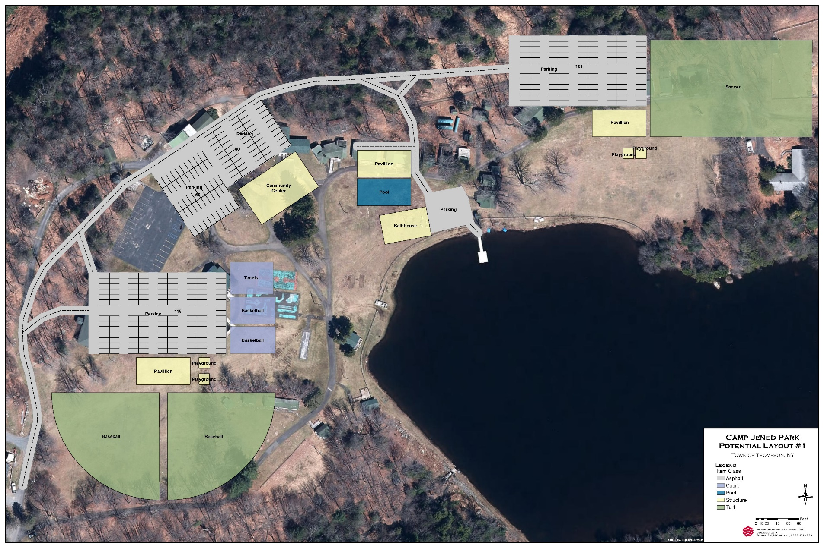
Potential Future Layout for former Camp Jened Layout #1
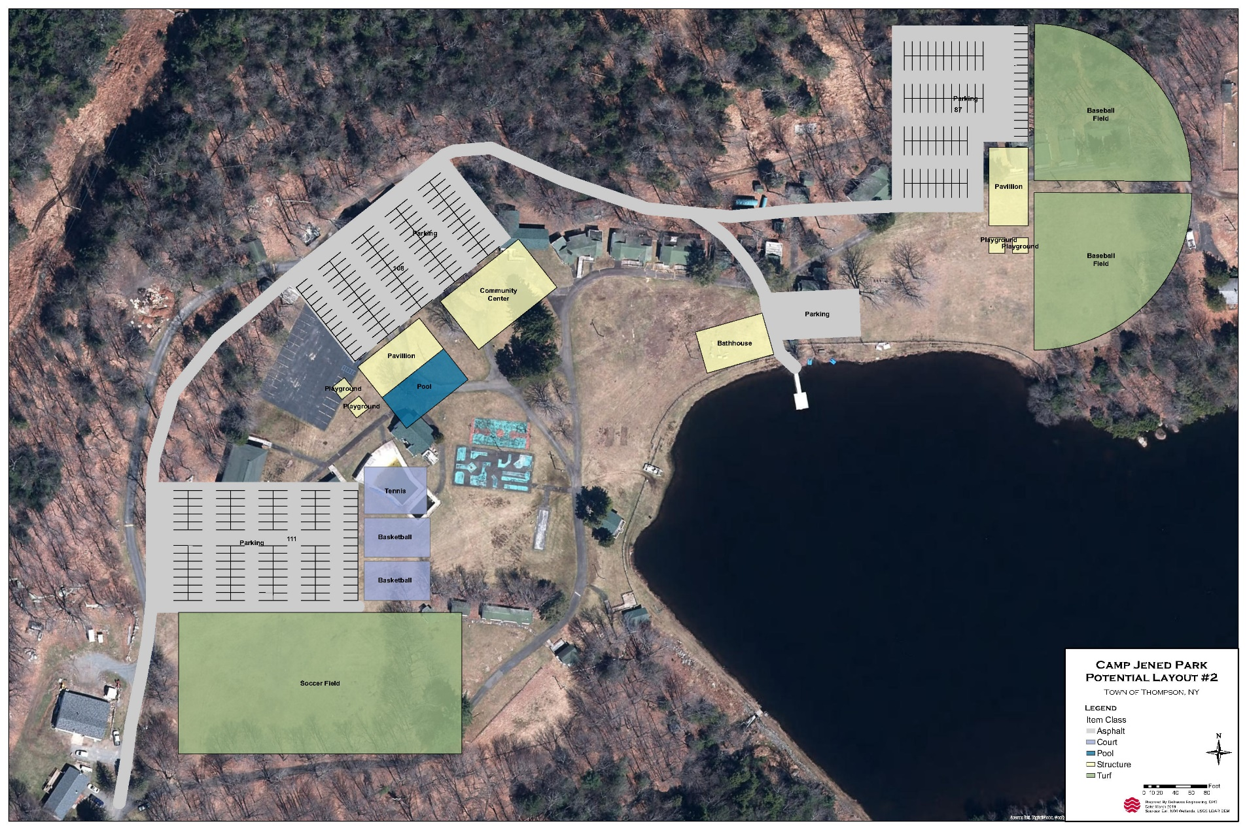
Potential Future Layout for former Camp Jened Layout #2

APPENDIX B
Survey Form

TOWN OF THOMPSON/VILLAGE OF MONTICELLO
PARKS AND RECREATION ONLINE SURVEY

- How often do you visit a public park in the Town of Thompson/Village of Monticello? (Check all that apply).
- Weekly (Spring - Fall)
- Weekly (Winter)
- Monthly (Spring - Fall)
- Monthly (Winter)
- Several times a year
- Never

- Which public park(s) do you visit? (Check all that apply).
- Town of Thompson Park
- Dillon Park
- De Hoyos Park
- New York State Forest (Wolf Brook/Neversink River Areas)
- None

3. What do you LIKE about the current public parks in the Town and Village? Please describe by location (Town of Thompson Park, Dillon Park and DeHoyos Park)
__________________________________________________________________________

4. What do you DISLIKE about the current public parks in the Town and Village? Please describe by location (Town of Thompson Park, Dillon Park and DeHoyos Park)
___________________________________________________________________________

5. What types of additional outdoor sports facilities would you like to be developed in the Town/Village park system? (Check all that apply).
- Tennis Courts
- Pickleball Courts
- Racquetball Courts
- Basketball Courts
- Volleyball Courts
- Skating Rink
- Frisbee Golf
- Soccer Fields
- Baseball/Softball Fields
- Track and Field
- Skateboard Park
- Other (Please describe in Question 9)

6. What types of additional recreational opportunities would you like to be developed in the Town/Village park system? (Check all that apply).
- Boating/canoeing/kayaking
- Lake swimming
- Fishing
- Playgrounds
- Picnic areas w/grills
- Dog Park
- Hiking Trails
- Cross-Country Ski Trails
- Ice Skating/Hockey
- Fitness Area
- Other (Please describe in Question 9)

7. What types of recreational programs would you like to see offered by the Town/Village? For example, an organized basketball league, swimming lessons or organized hikes.
____________________________________________________________________________

8. What types of rentable community spaces would you like to be developed in the Town/Village park system? (Check all that apply).
- Open Pavilions
- Indoor Event Space w/kitchen
- Indoor Sports Complex
- Bandshell
- Camping Cabins
- Other (Please describe in Question 9)

9. Have you ever visited a municipal park in another Town/County/State or Country, and if so, what was the most memorable thing about the visit?
___________________________________________________________________________

10. Please describe in a few words or sentences your vision of the future Town/Village park system.
___________________________________________________________________________

11. Please share any other ideas or comments that will help us develop plans for the future of the Town/Village park system.
___________________________________________________________________________

12. In what ZIP Code is your home located? (enter 5-digit ZIP code; for example, 00544 or 94305)

APPENDIX C
North Street Commons

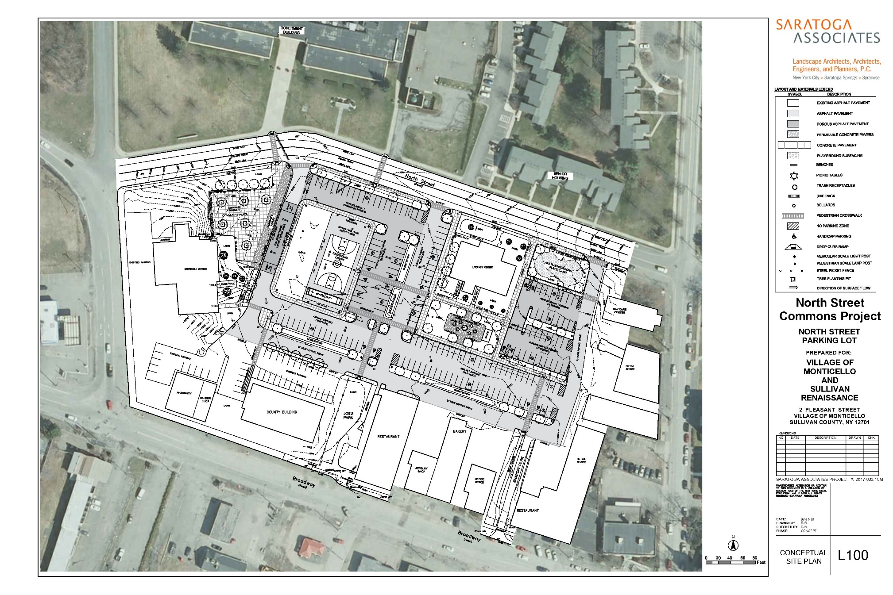
APPENDIX D
Dillon Park

